Class Implementation

Aubrey D. Soule
IT, Software Development and Coding, ECPI University
SDC330: Advanced Programming Using Java
Dr. Helio Castro
April 26, 2026

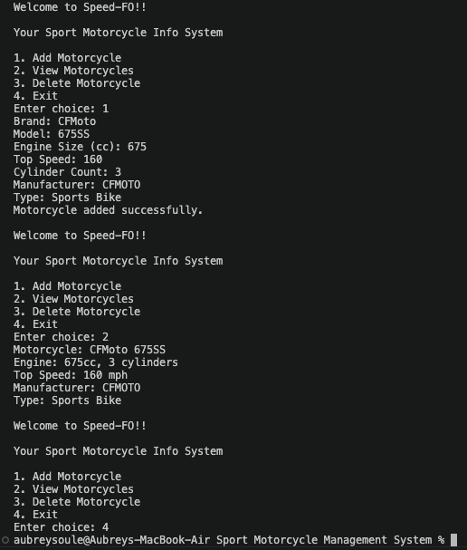
References

